3. PROPOSED SYSTEM ARCHITECTURE
The project ‘Productivity Companion’ features numerous time management methods and organizing techniques centered tabs which is in itself an app. The main application comprises of four sub-app namely Pomo Timer, Session Tracker, To-do list and Study planner. All these apps commonly includes various UI components to make the entire app interactive.

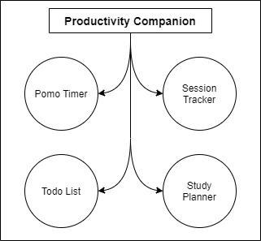
Figure 3.1: Basic overview
3.1 Individual App System Architecture
3.1.1 Pomo Timer
The prominent Promodoro Technique is incorporated via a simple timer with the added feature of rewarding the user for every pomodoro (interval). An initial timer of 25 minutes is allowed with higher limit being 120 minutes i.e. 2 hours. A knob that act as a handle sliding in circular path responsive to the user mouse movement is used to set the interval. Points for every pomodoro based on the length of interval is rewarded. An additional feature to this app might be the optional legal free copy-righted lo-fi song to play during the pomodoro.
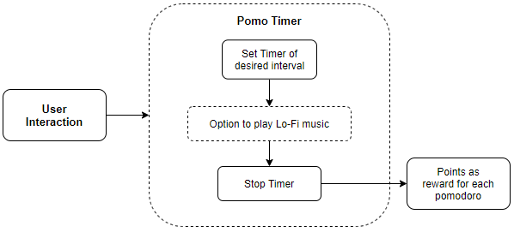
Figure 3.2: Pomo Timer Architecture
3.1.2 Session Tracker
Session tracking app that keeps track of time stamps and duration. User is provided with the option to manually type and create new session / project in the initial window. The created session tab consist of relevant parameters that best describe the session itself. This session tab opens in a new interactive session window which features a stop-watch that keeps track of the whole time taken by the project / task. On exit the model from the related database is updated.
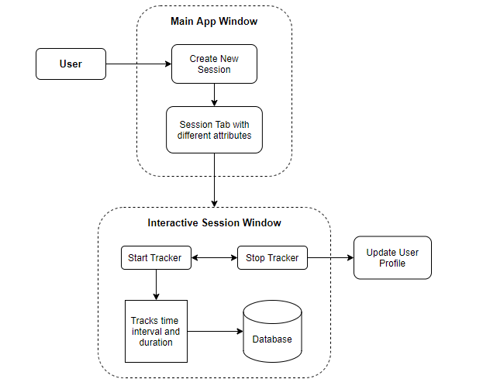
Figure 3.3: Session Tracker Architecture
3.1.3 To-do list
Ordered top-to-down listing of the task. Task added are represented in a div like element which includes editing / updating, remove option. Completion of any task is denoted by a strike through the task. Using CRUD on the related model in the local database the task is manipulated and stored.
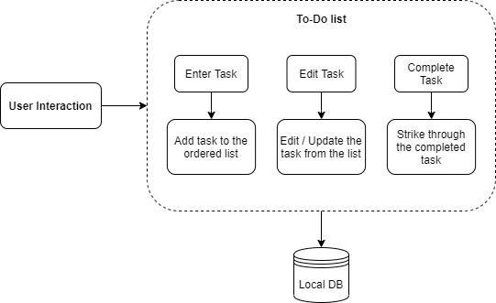
Figure 3.4: To-do List Architecture
3.1.4 Study Planner
The system architecture of ‘Study Planner’ is the amalgamation of both ‘Session planner’ and ‘To-do list’. It is the extended form of to-do list which features separate section for every topic as plan sheet. The plan sheet tab displays the required details related to it. Each plan sheet expands into a separate Plan Sheet window where adding, editing / updating of the task is accomplished. Completion of any task in the list is designated by a strike through. Using CRUD on the related model of the database, the information for all the plan sheet is handled and stored.
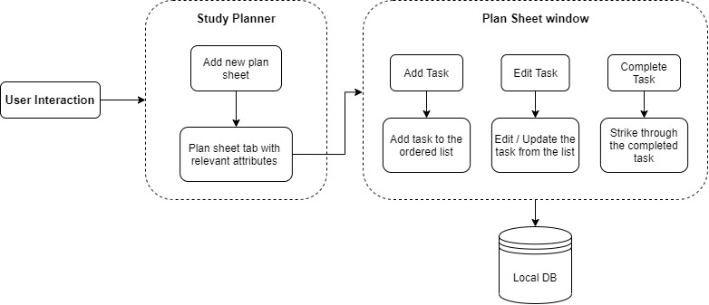
Figure 3.5: Study Planner Architecture
3.2 Data Flow Diagram
The main window displays four different sub-app that the user choose to navigate. The first app being the ‘Pomo Timer’. The only data flow in the Pomo Timer is the points that the user collects for every Pomodoro (interval) which is stored as a reward point.
The second tab features ‘Session Tracker’. The data handling in this app will require a simple model that keeps track of the time stamps and the duration along the date. The stored session data is loaded from the stored database. Any modification to the existing session will be updated to the corresponding session data.
The third tab ‘To-do List’ grabs any previous task data from the database and then loads it in the display view. Any modification to the list will be updated to the corresponding table as the tab is closed.
The final tab ‘Study Planner’ loads the plan sheet tabs if any into the initial display window. Each tab is a planner sheet that loads any previous task list in a separate interactive display window. Any modification to the planner sheet will be updated to the corresponding table as the sheet is closed.
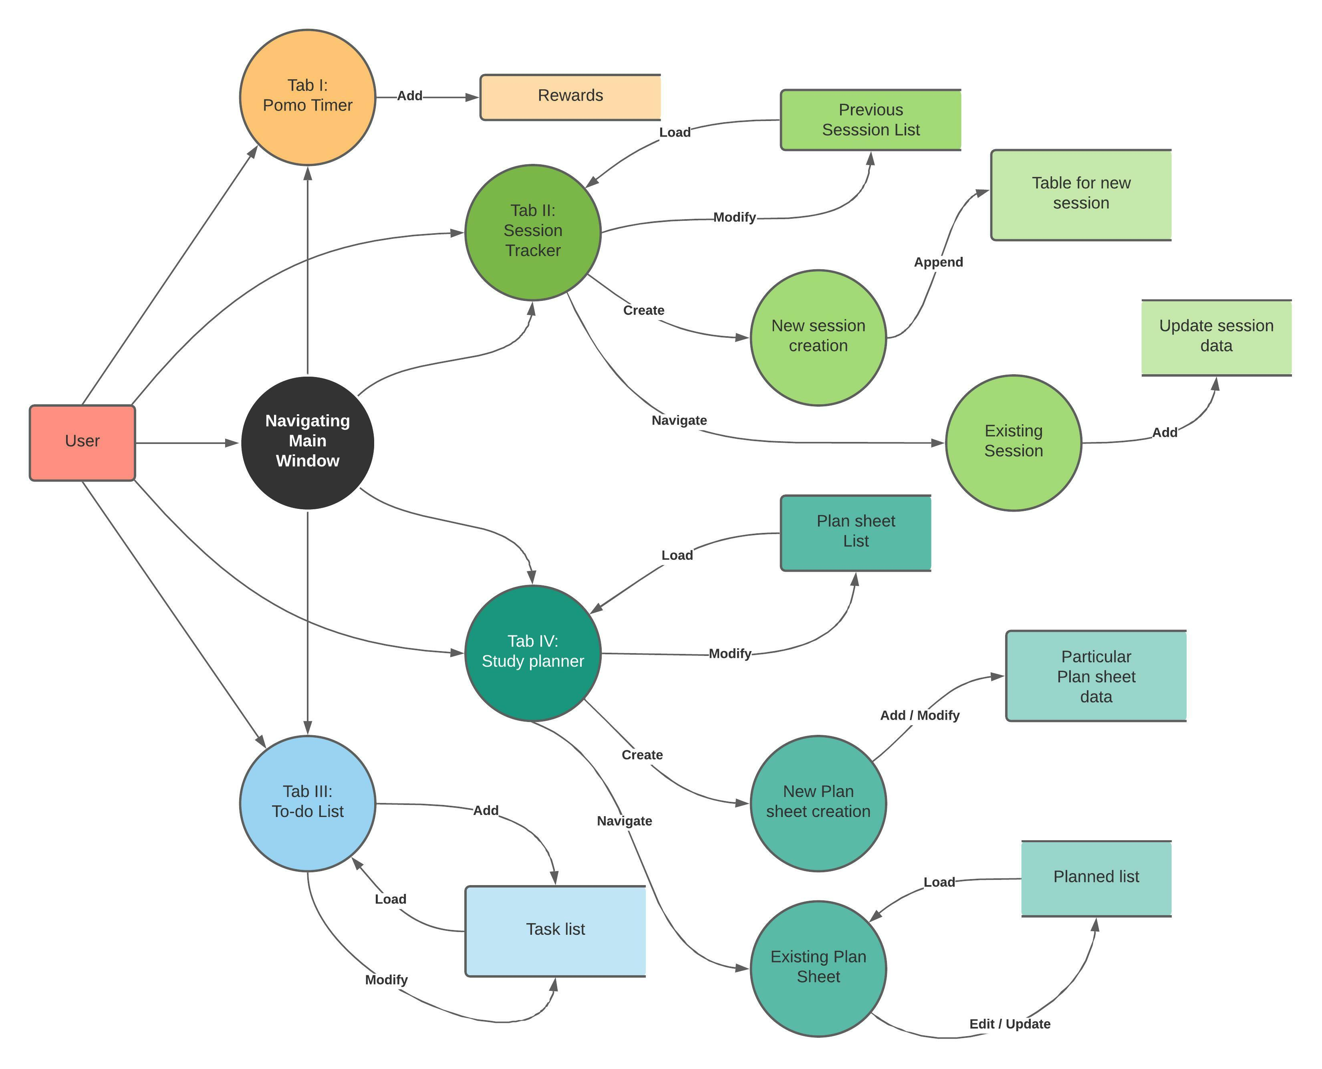
Figure 3.6: ‘Productivity Companion’ Data Flow Diagram (Yourdon-Coad Design)

